Hilltop Term 4 Newsletter 2024
Welcome back to term 4, we have another busy term planned for the children including celebrating:  ‘World book day’ on Thursday 7th March.  Children are welcome to dress up as their favourite story book character and bring in a book if they would like to.  (Please name books)  We continue our partnership with ‘Make Believe Arts’  Encouraging children’s language through learning new poetry each term, see the link for further information:  Home - MakeBelieve Arts  This term we are learning the poem’s ‘Popcorn and  ‘A little seed.’ | Term dates  Term 4 ends: Thursday 28th March 2024  Term 5 starts: Monday 15th April 2024  https://portisheadpreschool.co.uk/term-dates  Bank details – Portishead Pre-school  The Co-operative Bank  Sort code:08 92 99.  Account no: 67202728.  Please use your child’s name as reference when paying fees.  Fees  For fee queries/questions- Please email Christine Hunter (Business administrator) with any queries.  administrator@portisheadpreschool.co.uk  Funding  For funding queries, please email.  Sarah Bailey (Manager) manager@portisheadpreschool.co.uk |  | Contact details.  Brampton & Hilltop Pre-school  Manager: Sarah Bailey  manager@portisheadpreschool.co.uk  Business admin: Christine Hunter  administrator@portisheadpreschool.co.uk  Deputy/Safeguarding officer: Claire Godby  Health & Safety/Pre-school assistant:  Joanna Gill  Inclusion & SEND co-ordinator: Zoe Clarke  Pre-school assistant: Christine Hunter  Pre-school assistant: Kirsty-Ann Sweeney (maternity leave)  Tel. 01275 390947 Mobile: 07467 513997
Mother’s Day
To celebrate Mother’s Day, we would like to invite Mum’s to play at Hilltop Pre-school on Friday 8th March between 10:00-11:30. All Mum’s/ special person are welcome, this also includes children and their Mum’s who do not attend pre-school on Friday afternoon’s.
To enable us to collate numbers please inform the team if you will be attending.
Toy donations
If you have any good quality toys that your children have grown out of and you would like to donate them to the pre-school please email manager@portisheadpreschool.co.uk or inform the team. We are especially interested in toys for 2-year-olds.
Absence/illness  If your child is unable to attend pre-school, please contact the setting on 01275 390947 or email manager@portisheadpreschool.co.uk  as we are required to record absence.  Colds and viruses are common this time of year however If your child is unwell, please consider keeping them at home to minimise the risk of cross infection. Children who have sickness and/or diarrhoea must not attend pre-school for 48hours after the last episode. Diarrhoea and vomiting - NHS (www.nhs.uk) |  | Fundraising for pre-school  The Pre-school committee are arranging a May Fair event on Saturday 18th May celebrating 60 years of early years education for the community to raise funds for both Brampton & Hilltop Pre-school.  If you are able to help at the event, donate items or know a business that could offer sponsorship please email:thecommittee@portisheadpreschool.co.uk
Brampton & Hilltop Pre-schools- Learning through play.
Portishead Preschool Charity Number 1180880

Date & Topic | PSED | CL | PD | Literacy | Maths | KUW | EA&D | Home corner
19.02.24  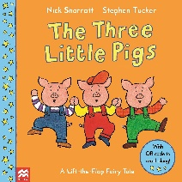 | How are the little pigs feeling?  What should you do if you feel upset? | Descriptive words  Straw,  Sticks,  Bricks,  Ask questions about the story for the children to think about?  “I wonder what would happen if… | Song  What’s the time Mr. Wolf  Encourage counting, stopping, and starting.  Song about  The 3 little pigs.  To the tune of  (Three blind mice) | Read  The Three little pigs  Poetry  ‘Popcorn’ | Counting,  Subitise,  Shape,  Construction,  Pig finds the house maze | Where do you live?  Can you draw your house,  Flat, bungalow?  Do you live in a house like your friend, grandparent?  Identifying and naming different buildings  What number is your house? | Make 2D houses.  Straw/hay, sticks, bricks  Use varying resources to build houses/dens. | Builders yard.  Interest in occupations  Resources to construct with.
26.02.24  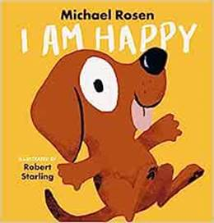 | Group time activity.  What makes you happy?  How do we know someone is happy?  Why do you think the dog in the story is happy? | Learning Makaton  Signs  Happy  Bing Videos  Love  Bing Videos  Calm  Bing Videos | Song  If you’re happy and you know it.  Happy song.  Jump,  Hop,  Skip,  Balance on one leg dance  Use bubbles.  Dance to different music to express how we feel. | Read  I Am Happy  Author  Michael Rosen  Poetry  ‘Popcorn’ | Counting  Gross motor skills  How many hops  Jumps, twirls?  Encourage children to record information on clip boards.  Counting balloons and bubbles activity sheet | Use playdough table create facial expressions on laminated face cards.  Do you have a pet? | Planting herbs.  What do they smell like?  What do plants need to grow? | Show time stage.  Musical instruments. Keyboard.  Different sounds  high/low
04.03.24  World book day  Thursday 7th March  Sunday 10th March Mother’s Day.  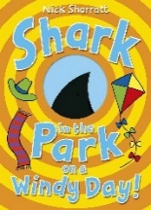 | Group time.  Listening activity  Identify the sound,  Identify the shape. | Rhyming words  Shark  Park,  Dark  Bark,  Lark,  Spark, | Song,  One, two, three, four, five once I caught…  5 little ducks went swimming one day.  Baby shark!  5 little jelly fish | Read  Shark in the park on a windy day  Nick Sharratt  Popcorn machine?  Poetry  ‘Popcorn’ | Counting,  Subitise,  Shape  identify sizes.  Big and small  Match the fish. | What else lives in the sea? | Make a kite.  Use primary colours.  How do we make the colour green?  Mother’s Day/special person cards.  Invite Mum’s  To play Friday 8th March 10-11:30 | Under the sea area  Water play
11.03.24  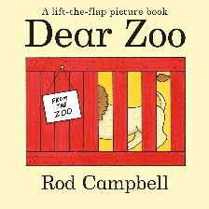 | Group time:  Do you have a pet?  Use Lola (Leopard) for listening activity and talk about pets’ children have or would like to have. | Descriptive words  Tall,  Fierce,  Big,  Small,  Writing letters  Practice letter and name writing. | Old MacDonald had a farm.  The lions in the zoo…add animals.  (Tune of the farmers in his den)  Can you move like a Lion, monkey, slither like a snake? | Read  Dear Zoo  Rod Campbell  Poetry  ‘A little seed’ | Counting,  Subitise,  Shape.  Estimating size?  Will a lion fit into this box?  Too big, too small? | Identify the animals. | Use varying resources to  Create Animal faces on plates.  Lion,  Monkey,  Elephant,  snake | Vets with animals from the story
18.03.24  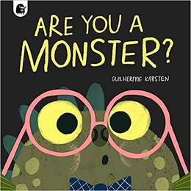 | Group time.  Looking at different dinosaurs  Carnivores -meat eaters and herbivores-plant eaters  What do you eat?  Golden rules  For everyone including monsters! | Colour monsters.  Identify feelings.  Happy,  Sad,  Angry,  Frightened,  Calm,  Loved. | 5 little monsters jumping on the bed.  What do monsters sound like and how do they move?  Follow a sequence stomp, stomp, clap. Clap, clap, stomp.  Roar and stomp like a monster. | Read:  Are you a Monster?  Author:  Guiherme Karsten  Poetry  ‘A little seed’ | Create monster shape pattern ABAB.  Go on a monster hunt, use spatial language such as, in, on, under, between.  Encourage the children to direct friends to where the monster is hiding. | Tuff spot  Colour monsters.  Can you match the monster colours?  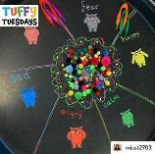 | Make  Junk model.  monsters | Monster cave.  Reading area.
25.03.24  Thursday 28th March. | Group time activity.  What is scary?  What should we do if we feel scared? | Descriptive words  Names of dinosaurs | Song  I’m a Giant Trex dinosaur.  (Tune of I’m a little teapot.) | Read:  There’s a dinosaur in your book.  Tom Fletcher  Poetry  ‘A little seed’ |  | Go on a dinosaur egg hunt.  Follow directional language.  Making Easter nests/cards  Cards  Discussion of Easter celebration | Bake a dinosaur Easter biscuit.  (Looking at ingredients, measuring.  Dinosaur printing, paint. | Tough tray  Dinosaurs in ice eggs  Dinosaur books provocation table  Textures.  What might a dinosaur feel like?  Brushes in the sand  Fossils and dinosaurs.
Popcorn  Popcorn, Popcorn, sizzling in the pan.  Shake it up, shake it up,  Bam, Bam, Bam.  Popcorn, Popcorn, now it’s getting hot.  Shake it up, shake it up,  Pop, Pop, Pop. |  |  |  | A little Seed  A Little seed for me to sow,  A little soil for it to grow.  A little hole, a little pat,  A little wish, and that is that.  A little sun, a little shower,  A little wait, and then a flower.

