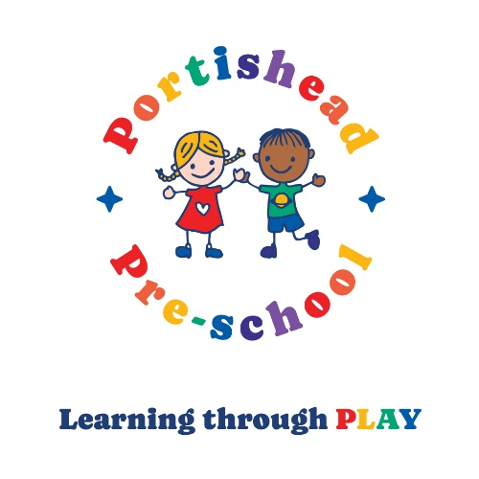
Brampton Pre-school and Hilltop Pre-school
Celebrating 60 years of early years education 1964-2024
We are now offering places from September 2024
Contact the settings to secure your child’s place on:
Brampton 01275 817834 (start from age 3 years)
Hilltop 01275 390947 (start from age 2 years)
Or click the link below to complete an online form:
Admissions – Portishead Pre-School (portisheadpreschool.co.uk)
Portishead Pre-school Registered Charity number 1180880

