Contact details  Brampton & Hilltop Pre-school Manager:  Sarah Bailey  manager@portisheadpreschool.co.uk  Business admin: Christine Hunter  administrator@portisheadpreschool.co.uk  Brampton Deputy: Sue Tiley  Pre-school assistant/Inclusion & SEND co-ordinator: Sally Targett  Pre-school assistant/Health and Safety officer: Helen Tarrant  Pre-school assistants: Sally Skuse, Ali Rowcliffe and Sarah Derrick  Brampton tel. 01275 817834  Mobile:07918 423377 | Term dates  Term 3 ends: Friday 9th February 2024  Term 4 starts: Monday 19th February 2024  https://portisheadpreschool.co.uk/term-dates  Bank details – Portishead Pre-school  The Co-operative Bank  Sort code:08 92 99  Account no: 67202728  Please use your child’s name as reference when paying fees.  Fees  For fee queries/questions- Please email Christine Hunter (Business administrator) with any queries.  administrator@portisheadpreschool.co.uk  Funding  For funding queries, please email.  Sarah Bailey (Manager) manager@portisheadpreschool.co.uk |  | Happy New year and welcome back to term 3!  I hope you all had a wonderful Christmas with your families and that this year will be a happy and healthy one for you all!  We can safely say the winter is here following now that the temperature has plummeted. Please can you ensure your child has a coat, hat, and mittens and lots of layers during this cold snap to enable them to stay warm.  This term we are excited to be working in partnership with the library to share stories with the children from authors who have been shortlisted for the Book Trust story time prize. Each week we will be looking at a different story and planning activities around this. There will also be activities the children will be given to complete at home. These consist of colouring sheets provided by the library.
Reminder snack charge starts January 2024
From this term a £9.00 charge is payable for snacks.
Invoices will be sent via email each term from Christine Hunter (Business admin). There are 6 terms in an academic year.
Absence/illness  If your child is unable to attend pre-school, can you please contact the setting on 01275 817834 or email manager@portisheadpreschool.co.uk  Colds and viruses are common this time of year however If your child is unwell, please consider keeping them at home to minimise the risk of cross infection. Children who have sickness and/or diarrhoea must not attend pre-school for 48hours after the last episode. Diarrhoea and vomiting - NHS (www.nhs.uk) |  | Fundraising for pre-school- Children’s raffle  This term we will be running a children’s raffle which includes children’s story books, Noah’s Ark voucher, a giant Peppa pig and much more!  Tickets will be on sale soon, details to follow… 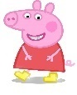  Portishead Preschool Charity Number 1180880
The deadline for school places is 15th January 2024 Apply now for 2024 school places | North Somerset Council (n-somerset.gov.uk) If your child is returning to Brampton Pre-school in September 2024 please email Sarah Bailey manager@portisheadpreschool.co.uk with your preferred sessions by 31st of January.

BookTrust Storytime Prize and voting | BookTrust – see link for authors reading their stories.
Display board split into 5 sections to display books and children’s creative skills.
Date & Topic | PSED | CL | PD | Literacy | Maths | KUW | EA&D
09.01.24  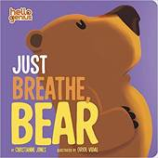 | Exploring feelings and self-regulation  Group time activity  Worried  Sad  Angry  Scared  Loved | Can the children describe these feelings e.g., sad?  Use Makaton to read story words.  Home learning resource  Follow the maze.  Activity. | Yoga  Mindfulness  Music  Honey pot bear  Song  Teddy bear, teddy bear turn around | Read  Just Breath Bear  Author  Christianne Jones  Children to vote.  Poetry:  Pancakes | Bear  Counting  Sorting  Patterns  Subitising | Where do bears live?  Tuff spot trays  Forest  Arctic  Desert  Grasslands | Make  Honey sandwiches  Home corner  3 little Bears house
13.01.24  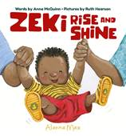 | What does your morning routine look like?  Group time activity  Sequence events:  Wake up!  Breakfast?  Get dressed?  What do you eat/drink at breakfast time? | Zeki Sequence cards- what happens next?  Descriptive words.  Home learning resource  Colour Zeki’s clothes | Songs  Head, shoulders, knees, and toes  Wash your dirty hands.  Importance of  Brushing teeth  Healthy eating, sleep routine and screen time. | Read  Zeki Rise and Shine  Author  Anna McQuinn  Poetry:  Pancakes | Exploring  Numbers/time  Patterns  Matching  Shape | Tuff spot tray  Textures and patterns descriptive words.  Crunchy, Smooth,  Bumpy, Shiny,  Pointy, spotty  Are jelly shoes made of jelly? | Make Bird feeders.  Home corner  (representation of story)  Bed, Clock  Breakfast dishes  Toothbrush, mirror, sink.  Animals in the story
22.01.24  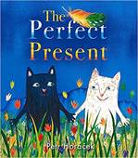 | Best gift we can give friends?  Group time activity  Be kind each other, Share and take turns,  Look after each other. | Practice letter/name writing  Home learning  Decorate a birthday cake | Party game songs  Parachute games  Team games  Rolling tyres  Use balls/balloons. | Read:  The Perfect Present  Author  Petr Horacek  Poetry:  Let’s put on our mittens. | Sea creatures  Counting  Sorting  Patterns  Subitising | Tuff spot tray  Items from the story  Feather, marble,  Umbrella, star,  Whale, Elephant  Etc. | Decorate strips of paper to create a friendship paperchain.  Home corner  Birthday party for Tom & Mot
29.01.24  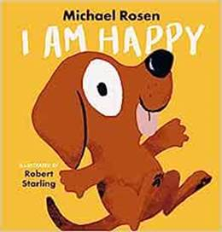 | Group time activity  What makes you happy?  How do we know someone is happy?  Why do you think the dog in the story is happy? | Makaton  Signs  Happy  Loved  Safe  Calm | Song  If you’re happy and you know it.  Happy song  Jump,  Hop,  Skip, dance  Use bubbles. | Read  I Am Happy  Author  Michael Rosen  Poetry:  Let’s put on our mittens. | Counting  How many hops,  Jumps, twirls?  Use charts to record in a set time.  Counting balloons and bubbles activity sheet | Tuff spot tray  Use playdough to create facial expressions on laminated face cards. | Make dog puppet.  Home corner  Show time stage to perform.  Theatre/puppets
05.02.24  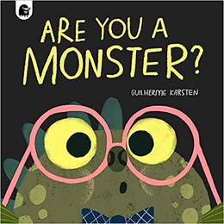 | Group time activity.  What is scary?  What should we do if we feel scared?  Golden rules  For everyone including monsters! | Colour monsters  Identify feelings.  Home learning resource  Monster activity sheet | 5 little monsters jumping on the bed.  What do monsters sound like and how do they move?  Follow a sequence stomp, stomp, clap. Clap, clap, stomp.  Roar and stomp like a monster | Read:  Are you a Monster?  Author:  Guiherme Karsten  Poetry:  Pancakes  Let’s put on our mittens. | Create monster shape pattern ABAB.  Go on a monster hunt, use spatial language such as, in, on, under, between.  Encourage the children to direct friends to where the monster is hiding. | Tuff spot  Colour monsters  Can you match the monster colours?  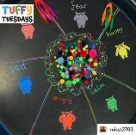 | Make  Junk model  monsters
Development Matters - Non-statutory curriculum guidance for the early years foundation stage (publishing.service.gov.uk)
Pancakes  Mix a pancake,  Stir a pancake,  Pop it in the pan.  Fry a pancake,  Toss a pancake,  Catch it if you can. | Let’s put on our Mittens.  Let’s put on our mittens, and button up our coats.  Wrap our scarves snuggly around our throats.  Pull on our shoes and fasten the straps,  And tie on tightly our warm woollen hats.  Open the door, and out we go.  Out, into the soft and feathery snow.  Crunch, crunch, crunch.

