 | Happy New year and welcome back to term 3!  I hope you all had a wonderful Christmas with your families and that this year will be a happy and healthy one for you all!  We can safely say the winter is here following now that the temperature has plummeted. Please can you ensure your child has a coat, hat, and mittens and lots of layers during this cold snap to enable them to stay warm.  This term we will looking at a different story each week and planning activities around this. This week has been all about Goldilocks and the three bears, which is why you may have seen honey sandwiches coming home! We are also looking at numbers, capacity, and sizing.  Please see the planning attached for further information. |  |  |  |  | Term dates  Term 3 ends: Friday 9th February 2024  Term 4 starts: Monday 19th February 2024  https://portisheadpreschool.co.uk/term-dates  Bank details – Portishead Pre-school  The Co-operative Bank  Sort code:08 92 99  Account no: 67202728  Please use your child’s name as reference when paying fees.  Fees  For fee queries/questions- Please email Christine Hunter (Business administrator) with any queries.  administrator@portisheadpreschool.co.uk  Funding  For funding queries, please email.  Sarah Bailey (Manager) manager@portisheadpreschool.co.uk |  |  |  | Contact details  Brampton & Hilltop Pre-school  Manager: Sarah Bailey  manager@portisheadpreschool.co.uk  Business admin: Christine Hunter  administrator@portisheadpreschool.co.uk  Deputy/Safeguarding officer: Claire Godby  Health & Safety/Pre-school assistant:  Joanna Gill  Inclusion & SEND co-ordinator: Zoe Clarke  Pre-school assistant: Christine Hunter  Pre-school assistant: Kirsty-Ann Sweeney (maternity leave)  Tel. 01275 390947 Mobile: 07467 513997
Reminder snack charge starts January 2024
From this term a £9.00 charge is payable for snacks.
Invoices will be sent via email each term from Christine Hunter (Business admin). There are 6 terms in an academic year.
 | Absence/illness  If your child is unable to attend pre-school, can you please contact the setting on 01275 817834 or email manager@portisheadpreschool.co.uk  Colds and viruses are common this time of year however If your child is unwell, please consider keeping them at home to minimise the risk of cross infection. Children who have sickness and/or diarrhoea must not attend pre-school for 48hours after the last episode. Diarrhoea and vomiting - NHS (www.nhs.uk) |  |  | School admissions  The deadline for school places is 15th January 2024 Apply now for 2024 school places | North Somerset Council (n-somerset.gov.uk) If your child is returning to Brampton Pre-school in September 2024 please email Sarah Bailey manager@portisheadpreschool.co.uk with your preferred sessions by 31st of January. |  |  | Change to drop off/pick-ups!  To support parents and encourage children’s further independence from Monday 15th January, we will be unlocking the main gate at drop off/ pick up times and ask that parents wait at the smaller gate where the team will support the children to enter/leave the classroom. We know that children settle much quicker when staff and parents support this process. This will also support the team to improve the speed of this transition. Please can you inform grandparents/others who may drop off or collect your children. Thank you. |  |  |  |  | Fundraising for pre-school- Children’s raffle  This term we will be running a children’s raffle which includes children’s story books, Noah ark voucher, a giant Peppa pig and much more!  Tickets will be on sale soon, details to follow…  Portishead Preschool Charity Number 1180880
09.01.24  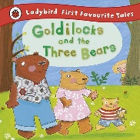 |  | Exploring feelings and self-regulation  Group time activity  Should Goldilocks have gone into the bears house?  Golden rules for Goldilocks and everyone. | Can the children describe these feelings e.g., sad?  Worried  Sad, Angry, Scared  Happy, Loved.  Learn Makaton for Happy, Sad, Loved |  | Honey pot bear  Song  Teddy bear, teddy bear turn around.  Stir up the porridge |  |  | Goldilocks and the three bears  Author:  Poetry:  Pancakes | Bear  Counting  Sizes  Sorting  Patterns  Subitising |  | Tuff spot tray  Use playdough to create facial expressions on laminated face cards.  Bears and goldilocks |  | Make  Honey sandwiches  Home corner  3 little Bears house
13.01.24 |  | What does your morning routine look like?  Group time activity  Sequence events:  Wake up!  Breakfast?  Get dressed?  What do you eat/drink at breakfast time? | Zeki Sequence cards- what happens next?  Descriptive words.  Home learning resource  Colour Zeki’s clothes |  | Songs  Head, shoulders, knees, and toes.  Wash your dirty hands.  Importance of  Brushing teeth  Healthy eating, sleep routine and screen time. |  |  | Read:  Zeki Rise and Shine  author: Anna McQuinn Poetry:  Pancakes | Exploring  Numbers/time  Patterns  Matching |  | Tuff spot tray  Textures and patterns descriptive words.  Crunchy, Smooth,  Bumpy, Shiny,  Pointy, spotty  Are jelly shoes made of jelly? |  | Home corner  (representation of story)  Bed, Clock  Breakfast dishes  Toothbrush, mirror, sink.  Animals in the story
22.01.24  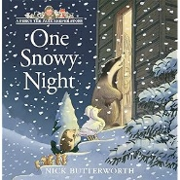 |  | Group time activity  Identifying and naming animals  Importance of keeping warm in the winter.  What should we wear.  How can we Look after wildlife? | Identifying  Animals  Descriptive words. |  | Practice  putting on coats  Zips  Gloves |  |  | Percy the park keeper  One Snowy Night  Author:  Nick Butterworth  Poetry:  Let’s put on our mittens. | Identifying and naming shapes.  Can you make  Percy’s house  Using the shapes |  | Tuff spot tray  Polar animals in ice  How does it feel?  Why does it melt?  Why does it freeze? |  | Make Bird feeders.  Home corner  Representation of story including words.  Badger, squirrel, mouse, owl, fox, bed, slippers
29.01.24  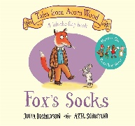 |  | Group time activity  What socks do you have on today?  Memory game  What is missing from a small group of items. | Rhyming words  Mat/hat  Fox/box  Clock/sock  Descriptive words  Name colours  Stripes, zigzags  Spotty |  | Spotty socks song  Hickory dickory dock |  |  | Fox’s Socks  Author  Julia Donaldson  Poetry:  Let’s put our mittens on | Matching  Counting  Go on a sock hunt, use spatial language such as, in, on, under, between.  Encourage the children to direct friends to where the matching sock is hiding. |  | Tuff tray idea  Match the patterns!  Match the socks!  Use assorted colours and varying patterns. |  | Design your own sock puppet.  Puppet theatre
05.02.24  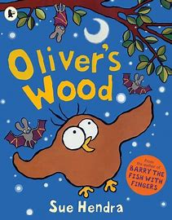 |  | Group time activity  Animals we see in the day and night. | Descriptive words  Day,  Night  Sun  Moon |  | 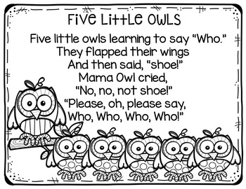 |  |  | Oliver’s wood  Author:  Sue Hendra  Poetry:  Let’s put on our mittens.  Pancakes | Counting  Sizes  Sorting  Patterns  Subitising |  | Tuff tray idea  Match the animals,  to the shape |  | Make owls.  Dark den  torches.
Development Matters - Non-statutory curriculum guidance for the early years foundation stage (publishing.service.gov.uk)
Pancakes  Mix a pancake,  Stir a pancake,  Pop it in the pan.  Fry a pancake,  Toss a pancake,  Catch it if you can. | Let’s put on our Mittens.  Let’s put on our mittens, and button up our coats.  Wrap our scarves snuggly around our throats.  Pull on our shoes and fasten the straps,  And tie on tightly our warm woollen hats.  Open the door, and out we go.  Out, into the soft and feathery snow.  Crunch, crunch, crunch.

