Hilltop Pre-school Term 6 Newsletter
Contact details.  Tel. 01275 390947 Mobile: 07467 513997  Manager Brampton & Hilltop: Sarah Bailey  manager@portisheadpreschool.co.uk  Business administrator: Christine Hunter  administrator@portisheadpreschool.co.uk  Deputy/Safeguarding officer/pre-school assistant: Claire Godby  Health & Safety/pre-school assistant:  Joanna Gill  Pre-school assistants: Christine Hunter, Zoe Clarke  Kirsty-Ann Sweeney (Maternity leave) | Hello and welcome to the final term before the summer holiday. The children have already learnt about dinosaurs, and this week we are looking at people who help us. We are also hoping we will have a visit from the fire fighters to talk with the children about what they do! |  | Consumable donation  We ask for a consumable donation of £9.00 each term, to enable us to purchase food for daily snacktime, ingredients for baking and craft resources. This charge is not currently mandatory; however, we are a registered charity and without receiving this donation, we would be unable to offer this service to the children and provide such a high range of activities. This can be paid directly into the pre-school account using the reference ‘Snack’ or by cash directly to the setting. Thank you.  Account name: Portishead Pre-school  Sort code: 08-92-99  Account number:67202728
Quiz night  The Pre-school committee has arranged a fundraiser Quiz night.  Venue: Portishead working Men’s Club  Date: Saturday 8th July.  Please email fundraiser@portisheadpreschool.co.uk for further details.  Cash can also be paid on the night to enter the quiz. | Sunny weather  Please ensure your child has a named  sun hat and is wearing suncream when they attend pre-school. Sandals and croc style shoes are lovely however they provide little protection for tiny toes when balancing, climbing, and using trikes and bikes. Please send children wearing footwear that covers their toes if possible. Thankyou |  | Sponsored obstacle course  Thank you everyone who sponsored their child to raise funds for pre-school. We raised £703.50 at Hilltop.  Thank you so much for your support, this money will be used to purchase new toys and equipment for the children.
Toy donations  If you have any toys that you would like to donate to the pre-school, please let Sarah/Claire know.  We are also looking for a new playhouse if anyone has one, they would like to donate. |  | End of year party  We will be having a party at Hilltop Pre-school for the all the children who attend the pre-school.  Date: Wednesday 19th July.  Time: 10:30-11:00am  Can you please let Sarah/Claire know if your child will be attending.
Portishead Pre-school Charity 1180880 |  | Term 6 ends on Wednesday 19th July  Term 1 starts on Monday 4th September.  Term Dates – Portishead Pre-School (portisheadpreschool.co.uk)

Term 6 planning 2023
Week | Topic | Activity | song | Home corner | Poetry | Books
1 | Dinosaurs | Dinosaur Foot printing – painting feet. Create 2D dinosaurs using just shapes. | Dinosaur, Dinosaur | Palaeontologist dig. Ice egg dinosaurs | If I were so very small | Relating to topic
2 | People who help us | Father’s Day (Special person) card  Fire fighter visit? | Fire Fighter song | Fire/police station  Doctors | If I were so very small | Relating to topic
3 | Floating and sinking | Experiment with resources  Make boats | 5 little ducks | Tuff trays with floating and sinking activities/experiments | Sliced bread | Relating to topic
4 | Shopping | Baking bread  Kids' soda bread recipe - BBC Food  Walk to shop – risk assessment | 5 current buns in the baker’s shop | Ice cream Shop  Bakery | Sliced bread | Relating to topic
5 | Under the sea | Making jelly fish | Wobbly jellyfish | Make a submarine | Monkey Babies | Relating to topic
6 | Pirates/At the beach | Making maps – Treasure hunt  Discuss sun safety | Pirate song | Treasure Island/boat | Monkey Babies | Relating to topic
7 | Mon/Tues  Continuation of at the beach | Last day of term Wednesday 19th July- Party  Hilltop 10:00-11:30am  Brampton 1:30-3:00pm  Ali- can you organise cakes for settings | All songs learnt through term | Kitchen/House | All poetry learnt through term | Relating to topic

Development Matters - Non-statutory curriculum guidance for the early years foundation stage (publishing.service.gov.uk)

Songs
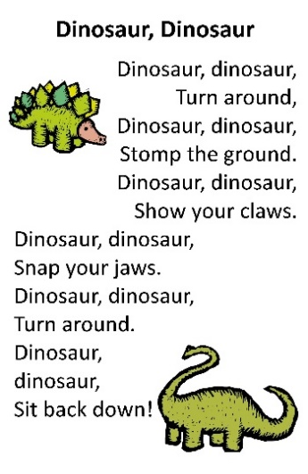 | 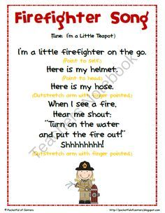 | 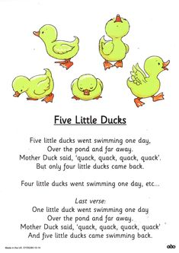
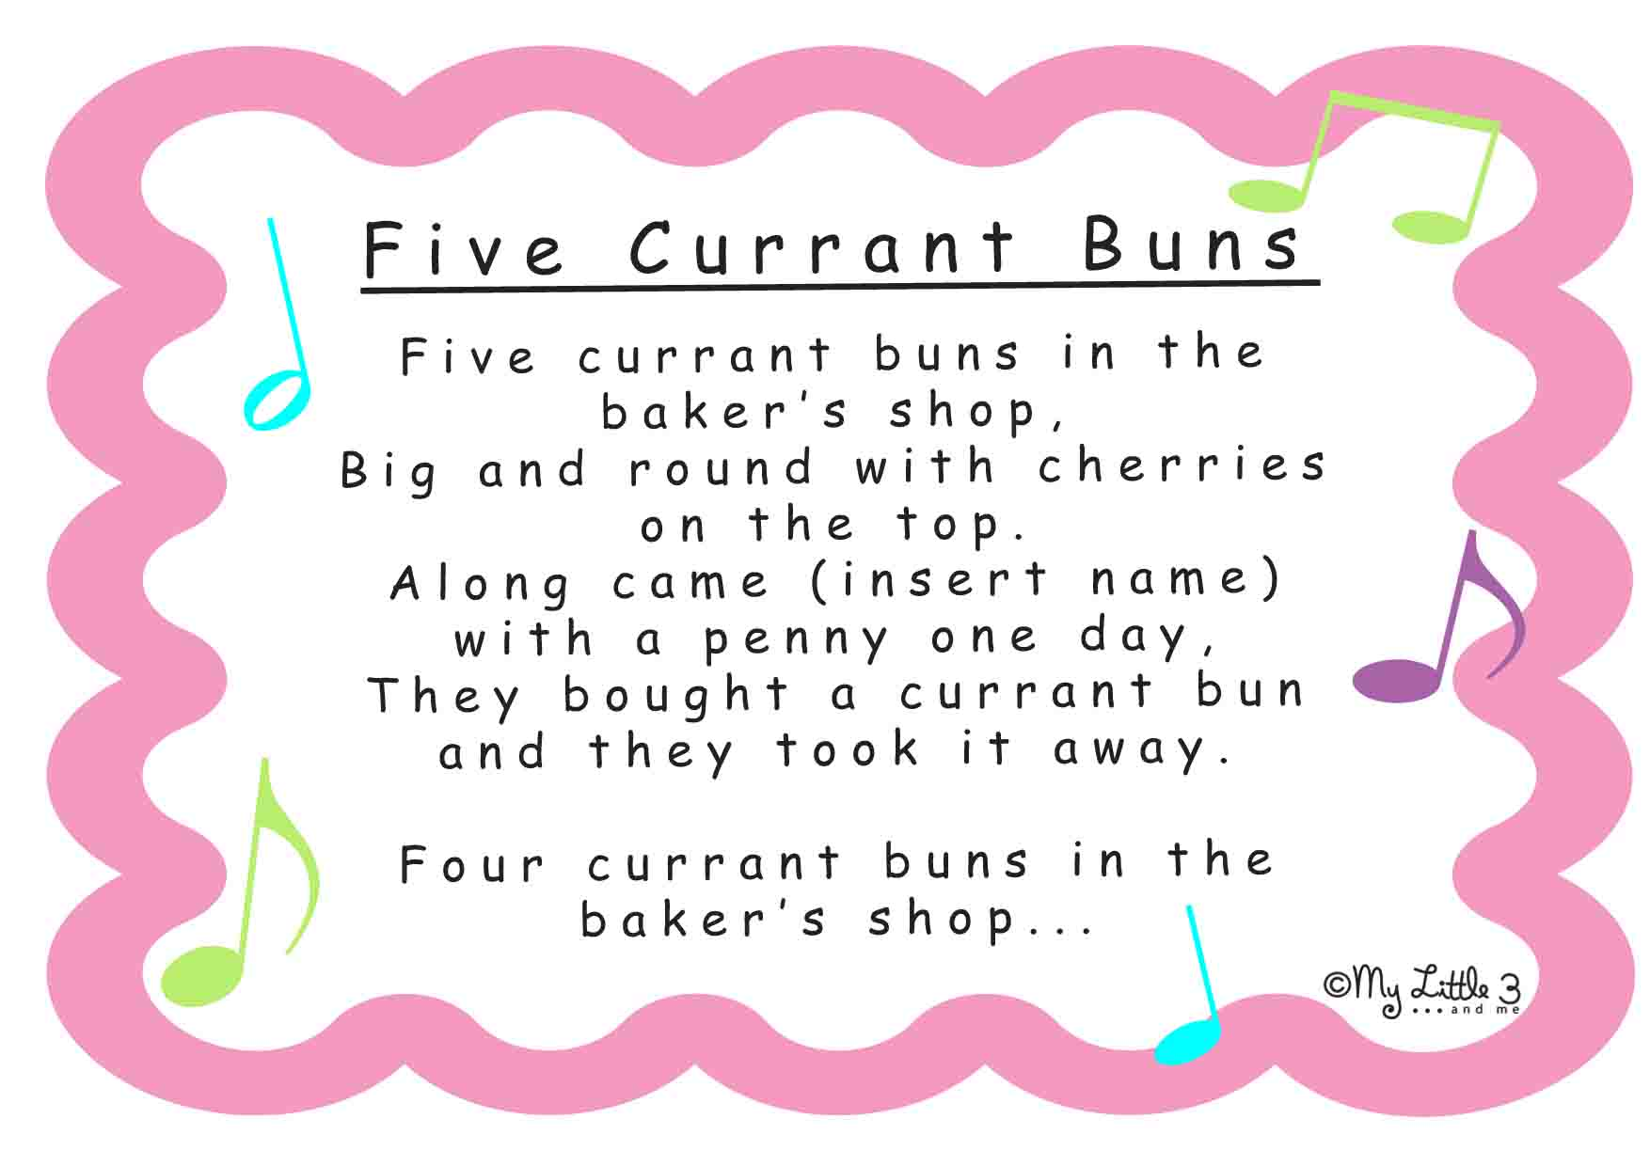 | Three wobbly Jelly fish  Three wobbly jelly fish, Three wobbly jelly fish,  Sitting on a rock, sitting on a rock,  One fell off, splash!  Two wobbly jelly fish, Two wobbly jelly fish,  Sitting on a rock, sitting on a rock,  One fell off, splash!  One wobbly jelly fish, One wobbly jelly fish,  Sitting on a rock, sitting on a rock,  And one fell off, splash!  Zero wobbly jelly fish, Zero wobbly jelly fish,  Sitting on a rock, sitting on a rock,  One came back, hurray!  One wobbly jelly fish sitting on a rock, hurray! | I’m a Pirate-Tune of ‘Frere Jacques’  I’m a pirate, I’m a pirate, On my ship, on my ship.  Looking for adventure, looking for adventure.  On a trip, on a trip.  Sailing the seas, sailing the seas,  Adventure, adventure.  Pirates are all looking, pirates are all looking,  On an island, on an island,  Have you guessed? Have you guessed?  Saw an X on the ground, saw an X on the ground,  Treasure chest, treasure chest.
Term 6 Poetry
Monkey Babies  by Irene Rawnsley and John Foster  Don’t leave your monkey baby sitting by a swamp.  A crocodile might eat him.  Chomp. Chomp. Chomp.  Don’t leave your monkey baby sitting in the breeze.  A snake might wrap around him.  Squeeze. Squeeze. Squeeze.  Don’t leave your monkey baby sitting on the track.  A lion might be lurking.  Snack. Snack. Snack.  Keep your monkey baby high up in the trees,  Feed him on bananas and pick off all his fleas. | Sliced Bread  Slice, slice, the bread looks nice.  Spread, spread, butter on the bread.  On the top put jam so sweet,  Now it's good enough to eat. | If I Were So Very Small  If I were so very tall,  I’d walk amongst the trees.  And stretch to reach the top most leaf,  As easy as you please.  And if I were so very small,  I’d hide myself away.  And creep into a buttercup,  To spend a summer’s day.

