Hilltop newsletter Term 2 / 2022
Contact details  Tel. 01275 390947  Mobile: 07467 513997  Manager Brampton & Hilltop: Sarah Bailey  manager@portisheadpreschool.co.uk  Business administrator: Christine Hunter  administrator@portisheadpreschool.co.uk  Deputy/Safeguarding officer/pre-school assistant: Claire Godby  Health & Safety/pre-school assistant:  Joanna Gill  Pre-school assistants: Kirsty-Ann Sweeney Christine Hunter, Zoe Clarke | Welcome back to Term 2  We have a busy term planned and so far, this week the children have taken part in fun activities for Halloween, learnt about the celebration of Diwali, made Diya lamps and rangoli patterns to take home and have made beautiful firework pictures and rockets!  Portishead Pre-school Facebook page is updated every Friday, have a look to see some of the activities the children have been participating in.  At the end of this newsletter, you will find planning for this term. | Portishead Victorian Evening  We are arranging to sing Christmas songs with the children at the Victorian evening in Portishead on Sunday 11th November. We would love you to bring your children to join us in the afternoon at this event to begin the  Christmas festivities!  There are songs on the planning sheet that the children will be learning this term, please practice these at home so we can all join in!  Time 3:30 -meeting point to be confirmed!
Weather changing  We play outside daily and to ensure the children can have fun and continue their learning outside, please can you provide a named waterproof coat, warm hat, and gloves. |  | Christmas party  We will be holding a Christmas Disco for all the children at Hilltop on the last day of term:  Friday 16th December between 10:30-12:00  If your child does not normally attend the setting on this day, they are also invited between these times.
Absence
This time of year, we tend to see more colds, coughs, and viruses.
If your child is unwell or you plan to have a holiday, can you please contact Sarah via email manager@portisheadpreschool.co.uk or contact the setting on 01275 390947 as we are required to record the reason for any absences.
Snack donation  We ask for a consumable donation of £9 each term, this covers morning and afternoon snacks, as well as activities, such as baking. This is not a mandatory fee, however without this being paid we would be unable to offer a healthy snack to all children and provide such a high range of activities. This can be paid directly into the Pre-school account. Co-op Bank 08-92-99 Acc.67202728 Please use reference ‘Snack donation’  Donations of toys/equipment  If you have something you would like to donate to the pre-school, please speak to the team.  We will also happily accept donations of boxed tissue for little runny noses! |  | Further information  Portishead preschool website: https://portisheadpreschool.co.uk/  Portishead preschool Facebook:  https://www.facebook.com/PortisheadPreSchool/.
Portishead Preschool is a registered Charity 1180880
PERSONAL, SOCIAL & EMOTIONAL | COMMUNICATION & LANGUAGE |  | PHYSICAL DEVEOPMENT |  | LITERACY
Hand washing- why is it important?  Understand behaviour expectations  Increasingly follow rules, understanding why they are important.  Play with one or more other children, extending and elaborating play ideas  Begin to understand how others might be feeling.  Continue to use Colour monster as tool to support understanding.  Sharing and visual timers | Learning the sounds, Listening to jolly phonics songs  S, A, T,P,I,N. Use sound board.  Enjoy listening to longer stories and can remember much of what happens.  Can start a conversation with an adult/friend and continue for many turns  Use a wider range of vocabulary  Use longer sentences of 4-6 words  Understand a question or instruction that has two parts, such as: “Get your coat and wait at the door.”  Begin to sing a large repertoire of songs |  | Continue to develop movement, balancing, riding, and ball skills.  Go up steps and stairs, or climb up apparatus, using alternate feet.  Skip, hop, jump, stand on one leg and hold a pose – Mindfulness Yoga.  Begin to be increasingly independent using the toilet, washing hands and drying them thoroughly and by putting on coats, doing up zips.  Use one handed tools and equipment such as making snips in paper with scissors. |  | Print has meaning and can have different purposes such as a recipe, shopping list, shop logos, road sign or show danger)  Encourage children mark make in a variety of ways.  Writing a letter to Santa.  We read English text from left to right and from top to bottom.  Name different parts of a book.  Stories  Diwali story  Stick man  Peppa pig and the lost Christmas List  The Nativity story  Songs  Firework song  Little lamps are burning bright/Firework song  Christmas songs
MATHEMATICS | UNDERSTANDING THE WORLD |  | EXPRESSIVE ARTS AND DESIGN |  | POETRY BASKET POEM FOR TERM
Subitising up to 3  Show finger numbers up to 5  Know that the last number reached when counting a small set of objects tells you how many there are in total (‘cardinal principle’).  Link numerals and amounts up to 5  Talk about and explore 2D and 3D shapes using informal mathematical language: ‘Sides’ ‘Corners’ ‘Straight’  ‘flat,’ ‘round’ | Celebrate and value cultural, religious and community events and experiences.  Halloween  Diwali- festival of light- Rangoli patterns  https://www.bbc.co.uk/cbeebies/watch/lets-celebrate-diwali  Firework night  https://www.bbc.co.uk/cbeebies/watch/bing-super-loud-fireworks  Christmas Nativity  https://www.bbc.co.uk/cbeebies/watch/presenters-nativity-story?collection=christmas  Continue to develop positive attitudes about differences between people.  Explore collections of natural materials with similar and or different properties  (Provocation table or Tuff tray)  Walking to post box to post Santa’s letter.  (Risk assessment- road safety-high vis jackets) |  | Begin to develop complex stories using small world equipment like animals and dolls and dolls houses.  Use drawing to represent ideas like movement or loud noises-Fireworks!  Explore colour and colour mixing.  Wall display: Christmas display  Remember and sing entire songs  Play instruments with increasing control to express their feelings and ideas.  Use junk modelling to make firework rockets.  Make a diya lamp  Make a stick man  Create Christmas decoration to take home and  Learn about Christmas story and practice songs.  Singing at Victorian evening with children  Sunday 11th Dec time TBC Parents to bring children to the event. |  | Pointy Hat  A little old lady with a tall, pointed hat,  K knocked on my door with a rat-a-tat-tat.  I peered through the window to see who was there,  And off on her broomstick, she flew through the air.  Breezy weather  B Breezy weather. Freezy weather.  When the leaves fall, we all fall together.  Br Breezy weather. Freezy weather,  W When the wind blows, we huddle together  Previous poetry  Chop, Chop  Christmas party last day of term:  Hilltop 10:30 -12:00  (Festive snack food to include fruit)
Incy Wincy Spider |  | Christmas pudding |  | Twinkle, twinkle little star
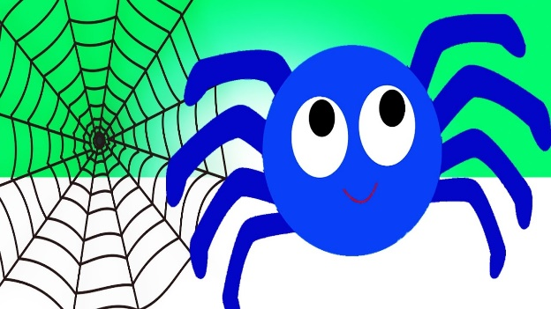  Incy Wincy spider,  Climbed up the Christmas tree.  Down came the snow and made poor Incy freeze.  On came the Christmas lights,  And melted all the snow.  So Incy Wincy spider,  Had another go. |  | Christmas pudding, Christmas pudding,  Serve it hot, serve it hot,  Sprinkle on the sugar, sprinkle on the sugar,  Eat the lot,  Eat the lot. |  | Twinkle, twinkle little star  How I wonder what you are  Up above the world so high  Like a diamond in the sky,  Twinkle, twinkle little star  How I wonder what you are

When Santa got stuck up the chimney | Jingle bells, jingle bells | We Wish you Merry Christmas | The Christmas Robot
When Santa got stuck up the chimney,  He began to shout  You girls and boys,  Won’t get any toys,  If you don’t pull me out.  My beard is black,  There’s soot in my sack,  My nose is tickling too!  When Santa got stuck up the chimney  Achoo, Achoo, achoo. | Jingle bells, jingle bells  jingle all the way!  O what fun it is to ride  in a one-horse open sleigh- Hey!  Jingle bells, jingle bells  jingle all the way!  O what fun it is to ride  in a one-horse open sleigh -Hey! | We wish you a merry Christmas,  We wish you a merry a Christmas,  We wish you a merry Christmas and a happy new year,  Good tidings we bring to you and your kin,  Good tidings for Christmas and a happy new year.  (Makaton)  https://youtu.be/a-PBixyD_GU | 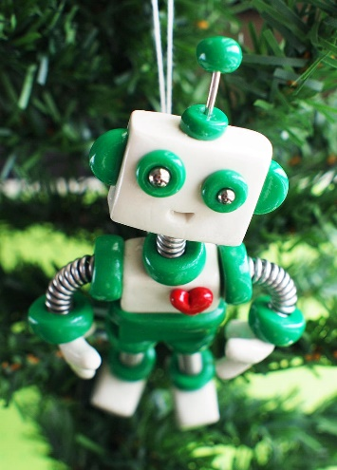  When the robot came to dinner,  He came on Christmas day,  He didn’t like the turkey,  So, he through it all away  He ate up all the knives and forks,  and then he asked for more  Oh, I’ve never had a Christmas dinner,  Quite like that before.  When the robot came to dinner  When the robot came to dinner  When the robot came to dinner  He came on Christmas day

