When Santa got stuck up the chimney
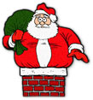

When Santa got stuck up the chimney,
He began to shout
You girls and boys,
Won’t get any toys,
If you don’t pull me out.
My beard is black,
There’s soot in my sack,
My nose it tickling too!
When Santa got stuck up the chimney
Achoo, Achoo, achoo.

Away in a manger
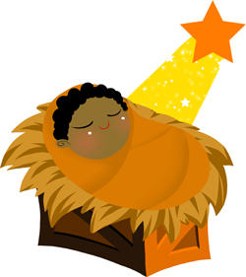

Away in a manger, no crib for a bed,
the little Lord Jesus, lay down his sweet head.

The stars in the bright sky, looked down where he lay,
the little Lord Jesus, asleep on the hay.

Twinkle, twinkle little star

Twinkle, twinkle little star
How I wonder what you are
Up above the world so high
Like a diamond in the sky,
Twinkle, twinkle little star
How I wonder what you are.

Jingle bells, jingle bells
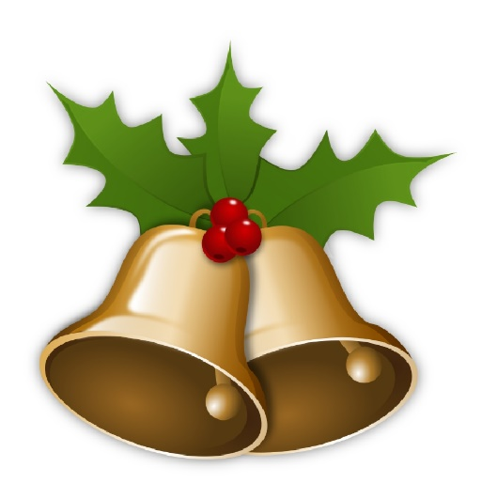

Jingle bells, jingle bells
jingle all the way!
O what fun it is to ride
in a one-horse open sleigh- Hey!
Jingle bells, jingle bells
jingle all the way!
O what fun it is to ride
in a one-horse open sleigh -Hey!

We wish you a merry Christmas

We wish you a merry Christmas,
We wish you a merry a Christmas,
We wish you a merry Christmas and a happy new year,
Good tidings we bring to you and your kin,
We wish you merry Christmas and a happy new year.

I’m a little snowman
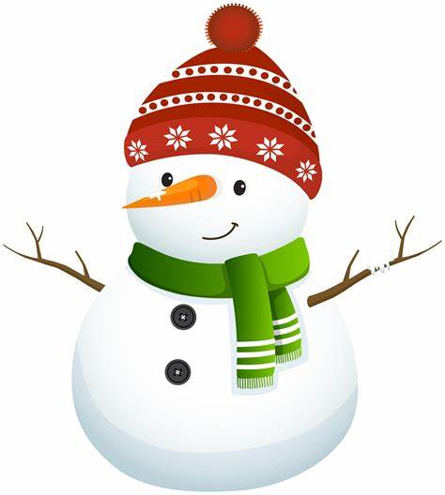

I’m a little snowman, short and fat,
Here’s my scarf and here’s my hat.
When the snow is falling,
He me say, girls and boys,
Come out to play.

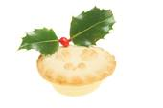

5 Mince pies
5 mince pies in the bakers shop big and round with sugar on the top,
Along came a customer, with a penny one day
Bought a mince pie and took it away
4 mince pies in the bakers shop big and round with sugar on the top
Along came customer, with a penny one day
Bought a mince pie and took it away
3 mince pies in the bakers shop big and round with sugar on the top
Along came customer, with a penny one day
Bought a mince pie and took it away
2 mince pies in the bakers shop big and round with sugar on the top
Along came customer, with a penny one day
Bought a mince pie and took it away
1 mince pies in the bakers shop big and round with sugar on the top
Along came a customer, with a penny one day
Bought a mince pie and took it away.

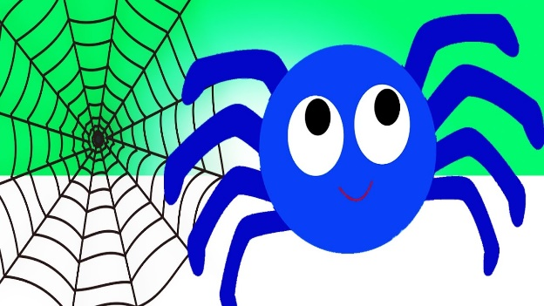

Incy Wincy Spider
Incy Wincy spider,
Climbed up the Christmas tree.
Down came the snow and made poor Incy freeze.
On came the Christmas lights,
And melted all the snow.
So Incy Wincy spider,
Had another go.

