Hilltop Pre-school Term 4 Newsletter February 2021
Dear Parent/carer,
Welcome back to term 4, the team are summarising the children’s learning this week and diaries will be sent home week commencing 1st March for you to see your child’s progress within their learning and development. Please do add to the diary your comments and anything you would like to share with us that your child is doing at home. I have added a new poem from our poetry basket project for the children to learn at home with you.
Contact details  Hilltop Preschool, St. Barnabas Centre, West Hill Portishead,  Bristol, BS20 6LN  Tel: 01275 390947 Mobile: 07914 449270 email:  Sarah Bailey: manager@portisheadpreschool.co.uk  Chris Hunter: administrator@portisheadpreschool.co.uk  The Committee: Thecommittee@portisheadpreschool.co.uk  Website: https://portisheadpreschool.co.uk/ |  | This terms topics  Healthy Eating  Looking after our bodies/Exercise and mindfulness  World book day Thursday 4th March (Children can dress as book character)  Mothering Sunday  Looking after Mini beasts  Nature theme- Birds in the garden  Easter
Poetry for home learning- Let’s put on our Mittens  Let’s put on our mittens and button up our coats.  Wrap our scarves snuggly around our throats.  Pull on our shoes and fasten the straps and tie on tightly our warm woollen hats.  Open the door and out we go,  Out into the soft and feathery snow.  Crunch, crunch, crunch. |  | Coats, bags, cardigans, sweatshirts, lunch boxes and drinks bottles.  It would really help the team if these items are named, we have up to 21 children in each session and not all children are aware of what belongs to them, please help us to reunite the correct belongings to their owners- Thank you
Bank details for payment
Portishead Pre-school bank details
Sort code: 543006
Account Number: 99648024
Please can you ensure when paying invoices that you use your child’s name as reference- Many thanks.
Term starts 4 ends Thursday 1st April Term 5 starts: Monday 19th April 2021
https://portisheadpreschool.co.uk/term-dates
Masks  We are all used wearing masks now in our everyday lives and even though government guidance is always changing we need to ensure that we keep each other safe from coronavirus and its variants. Please wear your mask unless exempt when dropping off or collecting your children from pre-school. Can you also inform any relatives in your bubble to wear masks if they collect your child from preschool for you.- Thankyou |  | Fundraiser  Pyjama day raised £30.00  At Hilltop Pre-school which we have used to invest in some new stories around anxiety for the children.  Thank you so much for your support.  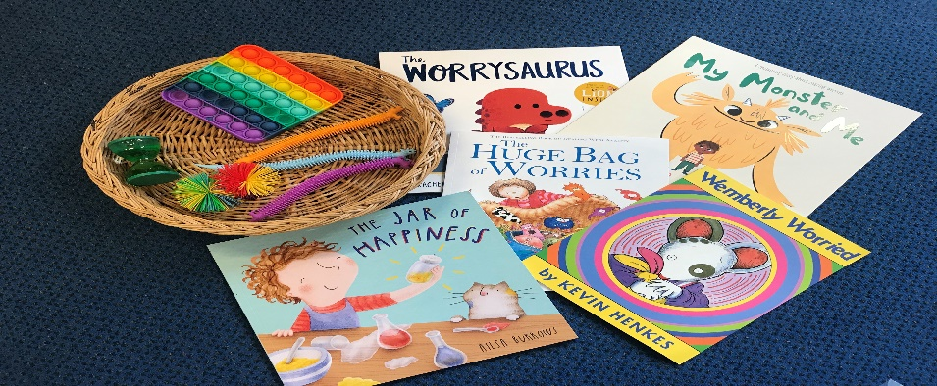  Look out for details coming home next term to sponsor your child to complete an obstacle course.  This year’s theme: Julia Donaldson books
Consumable donation
A consumable donation is charged at £8 each term, this covers morning and afternoon snacks, as well as some activities, like baking. This is not a mandatory fee, however without this being paid we would be unable to offer a healthy snack to all children and provide such a high range of activities.
Please use the bank details above and use your
child’s name and snack as reference
Lunch Club  We are noticing a large amount of confectionary items in children’s lunch boxes. We know that supermarkets are full of treats aimed at children however we do encourage healthy eating at pre-school and for children who attend all day it’s important that they have food that gives them energy to play and learn. Please keep sweets and treats for home and help to support us to encourage eating a healthy diet. | Gin & Games Night  The committee have organised a gin and games evening on Friday 26th February at 8pm.If you would like to participate in this fun event please email Sarah Farthing sarahf@portisheadpreschool.co.uk (Committee member) to register your interest. Bank details for payment are as follows: Sort code: 54 30 06 Account number: 99648024  Please use G&G then your name as reference.  Many thanks for supporting this event and have a wonderful evening.
Portishead Pre-school Charity 1180880

